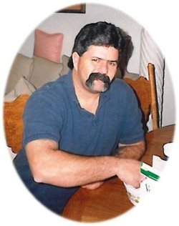

**Jerome Dewey “Jerry” Evans**

Birth: 23 Sep 1954

Walnut, Los Angeles County, California, USA

Death: 20 Dec 2013 (aged 59)

Wichita, Sedgwick County, Kansas, USA

Burial: [Kechi Township Cemetery](https://www.findagrave.com/cemetery/92814/kechi-township-cemetery)

Park City, Sedgwick County, Kansas, USA [Show Map](http://maps.google.com/maps?q=37.8000426,-97.3006929&spn=0.004205,0.005249)

Plot: Block 26; Avenue E

Memorial ID: 121980803

He was born in Walnut, California to Lawrence Eugene Evans and Margarett Lee Keterman. He was a graduate of Walnut High School. He is survived by his children, Eric Evans, Robert Evans, Angie Waterhouse, Cole Evans, Amber Burkholder, Joshua Wynn and Zachary Wynn; love of his life and friend Brenda Evans; grandchildren, Brandon Evans, Trenton Evans, Kolby Muldrow, Tyresse Waterhouse, Rodney Waterhouse, Naveah Watehouse, Ny-ia Waterhouse, Tagian Evans, Andrea Evans and Gabriella Burkholder; brothers, Gary Evans, Larry (Mary) Evans; sisters Cheryl Garcia and Kathy (Mark) McKim; many nephews, nieces, other family and friends. He is preceded in death by his dad Lawrence Evans, mother Margarett Ketterman and brother Terry Evans.

## Family Members

**Parents**



### Lawrence Eugene Evans

1923–2005

**Siblings**



### Terrance Lee Evans

1953–1971